Practical:01
AIM: Understanding the Sensor Node Hardware. (For Eg. Sensors, Nodes(Sensor mote), Base Station,Graphical User Interface.)
To study and understand the hardware components of a Sensor Node used in Wireless Sensor Networks, including Sensors, Sensor Motes, Base Station, and Graphical User Interface (GUI). Also to understand the data flow between these components.

COMPONENTS:
- Temperature/Humidity Sensor (e.g., DHT11- Digital Humidity and Temperature 11 (Digital Sensor) or LM35- Linear Monolithic 35 (Analog Sensor))
- Microcontroller board (e.g., Arduino, nodemcu units )
- Wireless Module (NRF24L01(Nordic Radio Frequency 2.4 GHz, version L01) / zigbee(wireless communication standard) / Wi-Fi(Wireless Fidelity))
- Base Station (Laptop / Raspberry Pi)
- Power Supply / Battery
- Computer with GUI software (Python/Tkinter or Web Dashboard)

THEORY:

Sensors:
Devices that measure physical parameters like temperature, humidity, pressure, gas, motion, etc. They convert real-world values into analog/digital signals.

Sensor Node (Sensor Mote):
A small electronic unit containing:
  - Sensor(s)
  - Microcontroller (processing)
  - Memory
  - Battery
  - Wireless Communication Module
It processes sensor data and transmits it to the base station.

Base Station:
A central device that collects data wirelessly from sensor nodes and forwards it to a computer or server.

Graphical User Interface (GUI):
Software used to display sensor readings in graphs, tables, gauges, or alerts.

Data flow diagram:
Sensor -> Microcontroller -> Wireless Module -> Base Station -> Computer -> GUI (Display) ->
Text Diagram:

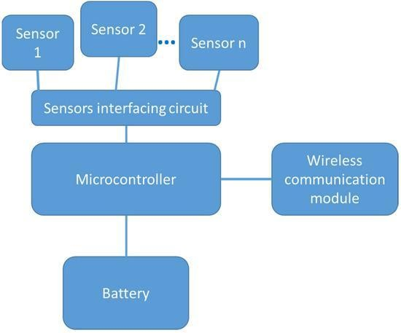
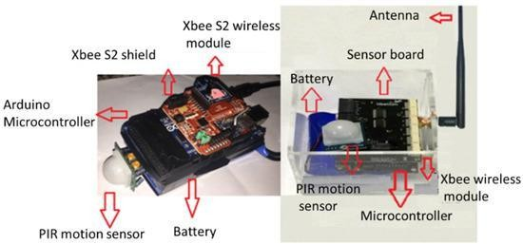

PROCEDURE:
- Connect the sensor (e.g., DHT11) to the microcontroller.
- Program the microcontroller to read sensor data.
- Interface the wireless module for communication.
- Power the sensor node using a battery.
- Configure the base station to receive data wirelessly.

- Create a GUI to visualize the data on a computer.
- Record and analyze the displayed data. OBSERVATION:
Sensor values such as temperature, humidity, or light intensity are received at the base station and displayed on the GUI.

RESULT:
The hardware flow of a sensor node system was successfully understood, including data movement from sensor to GUI through a sensor mote and base station.

Practical No:02
Aim : Understanding TinyOS computational concepts :- Events, Commands and Task.
- nesC model
- nesC Components

Explaination :
TinyOS:
- TinyOS is an open-source operating system designed for low-power wireless devices, particularly those used in sensor networks and Internet of Things (IoT) applications. It is characterized by its lightweight design, efficiency, and flexibility, making it suitable for resource-constrained devices.
- Originally developed at the University of California, Berkeley, TinyOS is written in the nesC (network embedded systems C) programming language, which is specifically designed for embedded systems and sensor networks.

Events:
  - Definition: Events represent asynchronous occurrences such as sensor readings, incoming messages, or timer expirations. They are declared within interfaces of components using the event keyword.
  - Event Handlers: Event handlers are functions that are called in response to the occurrence of an event. They are defined using the event qualifier.
  - Invocation: Events are raised (or fired) by components to signal the occurrence of a specific event using the call statement.
  - Registration: Components can subscribe to events raised by other components using the post statement.
  - Concurrency: Events are scheduled and executed in a non-preemptive manner. It's essential to write event handlers efficiently to avoid blocking operations.

Commands:
  - Definition: Commands represent actions that can be performed on a component. They are declared within interfaces of components using the command keyword.
  - Command Handlers: Command handlers are functions that implement the behavior associated with a command. They are defined using the command qualifier.
  - Invocation: Commands are called by other components or modules to perform specific actions using the call statement.

  - Execution: Command execution is synchronous, meaning that the caller waits for the command to complete before proceeding.
  - Parameters and Return Values: Commands can take parameters and return values, allowing for communication of data between components.

Tasks:
  - Definition: Tasks represent units of computation that are executed asynchronously. They are similar to functions or procedures in conventional programming languages but are executed asynchronously.
  - Task Handlers: Task handlers are functions that define the behavior of a task. They are defined using the task qualifier.
  - Scheduling: Tasks are scheduled for execution by the TinyOS scheduler. They can be scheduled to execute periodically, in response to events, or based on other criteria.
  - Concurrency: Tasks can run concurrently with other tasks and event handlers. It's crucial to manage concurrency effectively to avoid race conditions and ensure correct behavior.
  - Asynchronous Execution: Tasks execute asynchronously, meaning that they can be preempted by higher-priority tasks or events.

nesC model:
- nesC (network embedded systems C) is a programming language specifically designed for programming embedded systems and sensor networks, with a focus on efficiency and modularity. It was developed as part of the TinyOS project at the University of California, Berkeley. The language is primarily used in conjunction with TinyOS, although it can also be used independently.
- The nesC model encompasses several key features and design principles:
  - Component-Based Architecture: nesC promotes a component-based architecture, where software is divided into modular components that interact through
well-defined interfaces. Components encapsulate functionality and can be composed to build complex systems.
  - Interfaces: Interfaces define the contracts between components. They specify a set of commands, events, and sometimes configuration parameters that a component must support. Components can provide or use interfaces, allowing for modularity and code reuse

  - Wiring: Wiring is the process of connecting components together to form a complete system. It involves specifying how interfaces of different components are connected, allowing them to communicate and interact.
  - Concurrency: nesC supports concurrency through event-driven programming. Components communicate asynchronously through events and commands, allowing for efficient use of system resources and responsiveness to external events.
  - Static Configuration: Configuration parameters can be used to customize the behavior of components at compile time. This allows for flexibility and optimization while avoiding the overhead of runtime configuration.
  - Generic Programming: nesC supports generic programming techniques, allowing components and interfaces to be parameterized by types and values. This promotes code reuse and flexibility.
  - Efficient Resource Usage: nesC is designed to be highly efficient in terms of memory usage and execution speed. It achieves this by providing lightweight abstractions and optimizations tailored for resource-constrained embedded systems.

nesC components:
In nesC (network embedded systems C), components are the building blocks of the software architecture. They encapsulate functionality, promote modularity, and enable code reuse. Components in nesC follow a component-based architecture, where software is divided into modular units that interact through well-defined interfaces.
Components are defined using the keyword in nesC. Components interact with each other through interfaces. Interfaces specify a set of commands, events, and possibly configuration parameters that a component must support.

Steps: Install TinyOS on Ubuntu:
Step 1: Update Your System sudo apt update
sudo apt upgrade
Step 2: Install Required Packages
sudo apt install git build-essential python3 python3-pip default-jdk make Step 3: Install TinyOS Toolchain
sudo apt install tinyos-tools tinyos-source Step 4: Set TinyOS Environment Variables Add to .bashrc:
export TOSROOT=/opt/tinyos-2.x export TOSDIR=$TOSROOT/tos
export CLASSPATH=$CLASSPATH:$TOSROOT/support/sdk/java export MAKERULES=$TOSROOT/support/make/Makerules
Then run:
source ~/.bashrc
Step 5: Test TinyOS Installation

tos-check-env
Option 2: Install TinyOS on Windows (Using Ubuntu via WSL) Step 1: Enable WSL:
wsl --install
Step 2: Open Ubuntu from Start Menu

Step 3: Follow the Ubuntu installation steps mentioned above. Testing TinyOS Example Program
Go to the TinyOS Blink app: cd $TOSROOT/apps/Blink Compile:
make micaz install

Practical No: 03
Aim : Understanding TOSSIM for
- Mote-mote radio communication
- Mote-PC serial communication

Explanation :
TOSSIM stands for TinyOS Simulator. It is a simulation environment for TinyOS- based wireless sensor networks. TOSSIM allows developers to test and debug their TinyOS applications without the need for physical hardware, providing a convenient and efficient way to experiment with different network configurations, algorithms, and protocols.

Mote-Mote Radio Communication:
In a Wireless Sensor Network,we use many tiny devices called motes.
Mote–mote communication means one sensor node (mote) sends data to another mote using radio signals.
How It Works in TOSSIM
- Mote A sends a wireless message.
- Mote B receives it using a radio.
- Each mote has a radio component.
- When one mote sends a message:
  - TOSSIM checks signal strength.
  - It checks noise level.
  - It checks if the motes are connected.
- If conditions are good → message is delivered.
- If signal is weak → message may be lost. In TOSSIM:
- The radio communication is simulated.
- The PC creates a virtual wireless environment.
- It uses a radio model to decide which mote receives the message.

Each mote has:
- A small sensor
- A tiny processor
- A small battery
- A radio to communicate wirelessly
What is mote-to-mote communication?
It simply means one mote talking to another mote wirelessly using radio signals.
Just like two mobile phones talk using signals, motes also send messages to each other using their built-in radio.
How they communicate
- A mote sends data (like temperature or humidity) using radio waves.
- Another mote receives it.
- They can pass messages directly or through multiple motes (multi-hop). Example:
Mote A → Mote B → Mote C (Data travels hop-by-hop)
Addresses :
Each mote has a unique ID, like a roll number, so they know who to send messages to
Routing :
In bigger networks, motes use routing protocols to find the best path to send data— just like Google Maps finds the best route.
Energy Saving :
Motes run on tiny batteries, so they must save energy. They do this by:
- Sleeping most of the time
- Waking up only to send/receive data (called duty cycling)
Mote-to-mote communication = small sensor devices sending wireless messages to each other using radio, while saving energy.
Mote-PC Serial Communication:
Mote-to-PC serial communication means a sensor node (mote) is connected to a computer so they can exchange data—like sending sensor readings from the mote to the PC.
Think of it like a wired chat between the mote and the computer.

How it works:

The mote has a tiny communication unit called UART
  - It allows the mote to send and receive data one bit at a time.

The PC connects using a USB or serial port
  - Often we use a USB-to-serial converter.

A cable connects the mote and the PC
  - USB cable or serial cable.
Both must use the same settings
For proper communication, both must match these values:
- Baud rate (speed of communication)

Data bits
- Parity (error checking)

Stop bits

These are like agreeing on a common language so both understand each other.
What happens during communication?
- The mote sends sensor data → PC displays it.
- The PC can also send commands → mote acts on them.

Error checks (like checksum) ensure the data is correct.

- Example:
PC asks: "Send temperature?"
Mote replies: "Temperature = 28°C"

Mote-to-PC serial communication = a wired connection between a mote and computer using serial protocols (UART/USB) to send and receive data reliably.
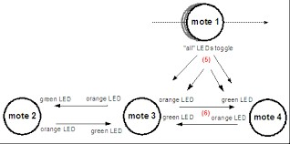

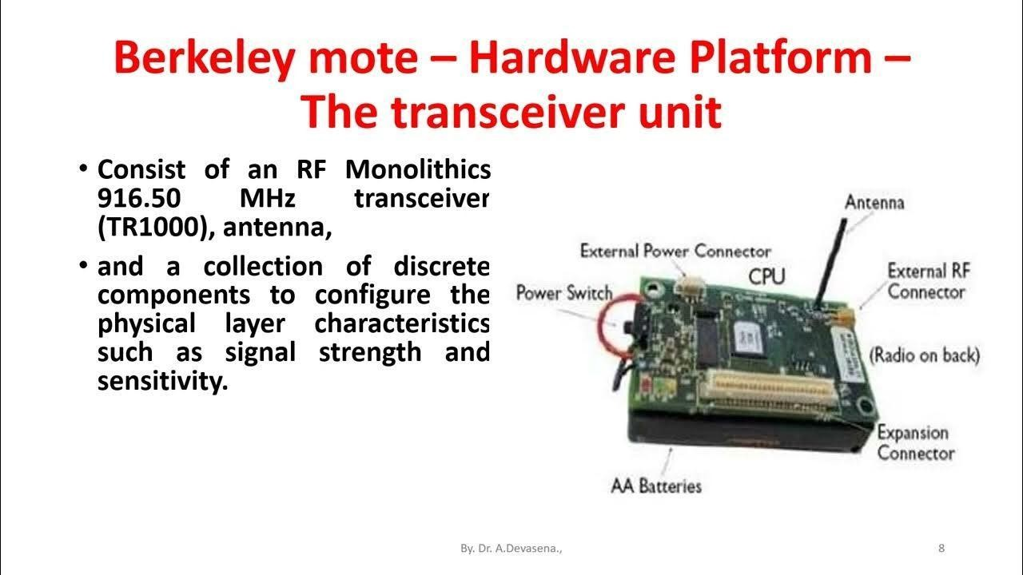

Practical No:04 Aim: Creating and Simulating a Simple Ad-Hoc Network Objective:
- To configure and simulate a wireless ad-hoc network where devices
communicate without a centralized access point.
Components Required:
- 2 or more PCs/laptops

Wireless Network Interface Cards (WNIC) in the PCs

- Cisco Packet Tracer software

Steps:
Step 1: Open Packet Tracer:

- Launch Cisco Packet Tracer on your PC.

- Save your project with an appropriate name.

Step 2: Add Devices:

- From the Devices Panel, select End Devices → drag 2 or more laptops
the workspace.

- Click on each laptop → check Physical Tab → make sure Wireless NIC is installed.

Step 3: Configure Wireless Settings
- Click on a laptop → Desktop Tab → PC Wireless.
- Set Mode to Ad-Hoc.
- Give the Network Name (SSID), e.g., AdHocNet.
- Optionally, set Channel and Security (if required).
- Repeat the same configuration for all laptops, ensuring they use the same SSID. Step 4: Assign IP Addresses
- Click on each laptop → Desktop Tab → IP Configuration.
- Assign a static IP address for each device in the same subnet. Example:
  - Laptop1 → IP: 192.168.1.2, Subnet: 255.255.255.0
  - Laptop2 → IP: 192.168.1.3, Subnet: 255.255.255.0
  - Laptop3 → IP: 192.168.1.4, Subnet: 255.255.255.0

Step 5: Test the Network

- Click on Laptop1 → Desktop → Command Prompt.

Ping the other laptops to check connectivity: ping 192.168.1.3
ping 192.168.1.4

- If the ping is successful, the ad-hoc network is working.

Step 6: Optional – File Sharing or Chat
  - You can test further using PC Applications → Chat or File Transfer in Packet Tracer to simulate communication over the ad-hoc network.
Step 7: Save and Document

  - Save your simulation file.

  - Take screenshots of IP configurations, ping results, and network topology for your report.

Output:
  - All devices in the ad-hoc network should communicate directly with each other without any router or access point.

  - Ping responses should be successful, confirming connectivity.

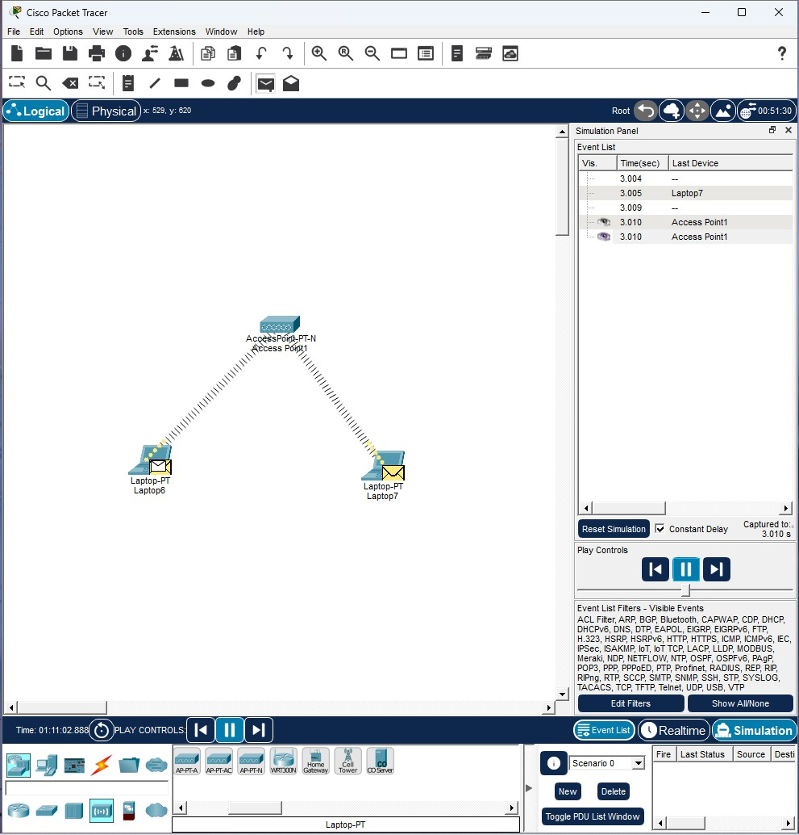

PRACTICAL NO.5:
Aim: Understanding, Reading & Analyzing Routing Table of Network

Required Tools / Software:
    - Windows
    - Command Prompt Terminal
    - Basic network connectivity Theory:
A routing table is a list stored inside routers or computers that tells the system where to send data packets.

Every time you access Google, YouTube, or any website, your PC checks the routing table to decide:
    - Which network interface to use
    - Which gateway to send packets to
    - Which network belongs to the local LAN
    - Which packets must go outside the network Routing Table Contains:
Field Meaning
Destination: The network or IP address where data has to go Netmask: Defines the network range.
Gateway: The next hop (router) used to reach the destination. Interface: Which network card (LAN/WiFi) will send the packet.
Metric: Priority / cost of the route (lower = higher priority).
Types of Routes:
- Directly Connected Routes Your own network.
Example: 192.168.1.0/24 → your LAN.
- Default Route
Used when no other route matches. Example: 0.0.0.0 via your WiFi router.
- Static Routes
Manually added by administrator.

- Dynamic Routes

Automatically learned by routers using protocols (RIP, OSPF, EIGRP etc.)

Commands Used:
Windows cmd:

route print ipconfig
tracert <IP Address>
Procedure (Windows Example) Step 1: Open Command Prompt
- Press Windows
- Type cmd (Run as Administrator)
- Press Enter
Step 2: View Routing Tabl
Type:
route print
You will see sections like:
- Interface List
- IPv4 Route Table
- IPv6 Route Table

Step 3: Identify Default Route

Look for:
0.0.0.0 0.0.0.0 192.168.1.1
This means:
  - All unknown traffic goes to 192.168.1.1 (your router).
Step 4: Identify Directly Connected Networks Example:
192.168.1.0 255.255.255.0 On-link
This shows your LAN network.
Step 5: Check Interface Example:
192.168.1.101 (your laptop’s IP) Step 6: Analyze Route Metrics
Look at metric values; lower metric = highest priority. Step 7: Use Tracert to Observe Real Packet Path Example:
tracert 8.8.8.8
This displays each hop (router) the packet travels through. Observation:
- The routing table contains default routes, local network routes, and interface routes.
- The default route is used to send packets outside the network.
- Directly connected routes help identify local network segments.
- Metrics determine route preference.

Result:

We successfully viewed and analyzed the routing table using networking commands. We understood the route entries, default gateway, connected networks, and route metrics.

Diagram:
PC > Router > Internet
(Default Gateway) Routing table:
Destination Gateway Interface 192.168.1.0 On-link LAN
0.0.0.0 192.168.1.1 WiFi

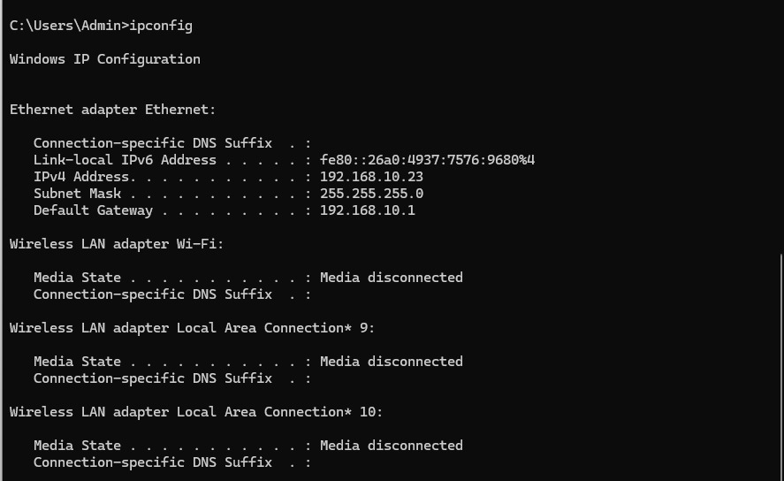

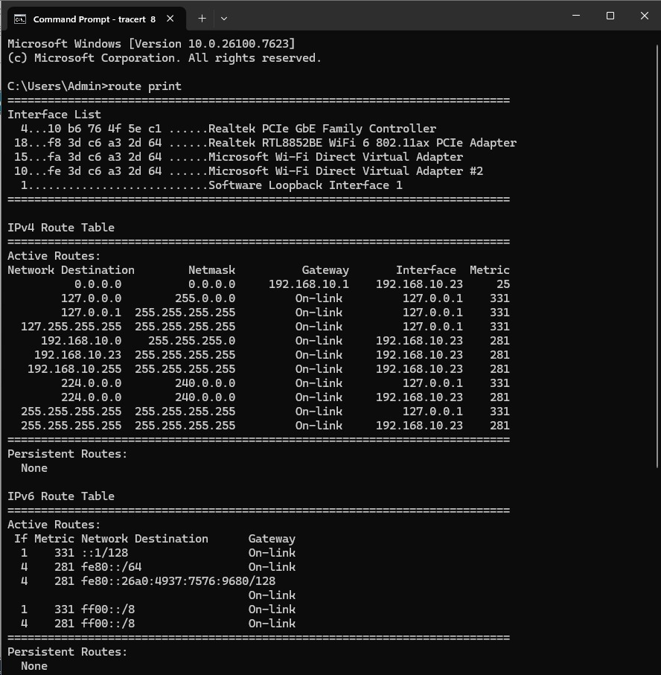

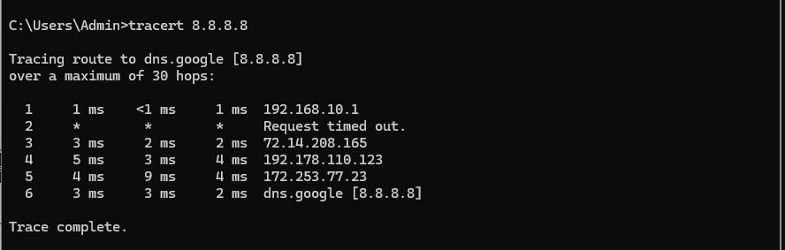

PRACTICAL No.06
Aim : Create a basic MANET implementation simulation for Packet animation and Packet Trace

Tool: Cisco Packet Tracer Difficulty: Beginner
Devices Used: Wireless End Devices + Wireless Router (or Wireless Mode Ad-Hoc) Concept:
MANET is a mobile wireless network with no central router. Every device communicates peer-to-peer with others.

In Packet Tracer, this is done using Ad-Hoc Wireless Mode.

STEPS TO CREATE BASIC MANET IN CISCO PACKET TRACER

STEP 1: Open Packet Tracer

Start Cisco Packet Tracer → New Project. STEP 2: Add 3–5 Wireless Nodes
From the End Devices section:
- Select Laptop or PC Wireless
- Place 3 or more laptops on the workspace (Example: Laptop0, Laptop1, Laptop2)
STEP 3: Enable Wireless Interface Click each laptop → Physical Tab
- Remove Ethernet (if shown)
- Insert Wireless WPC300N Module

.Power ON again if needed

STEP 4: Configure Wireless Settings to MANET

Click a laptop → Desktop → PC Wireless → Connect Tab Change the following:
Wireless Mode → Ad-Hoc

This is the MOST important step (Ad-hoc = MANET).

Set:

- Network Name (SSID): MANET
- Channel: 6 (or any same channel)
- Security: None (for basic simulation)

Repeat for all laptops.
Ensure all nodes use SAME SSID.

STEP 5: Assign IP Addresses (Static) Go to:
Desktop → IP Configuration Assign IPs:
Laptop0:

IP: 192.168.1.1
Subnet: 255.255.255.0
Gateway: (leave blank) Laptop1
IP: 192.168.1.2
Subnet: 255.255.255.0

Laptop2

Play Simulation

You will see a small envelope packet move from one laptop to another. This shows the wireless MANET communication.
STEP 10: Move the Nodes (Optional for MANET Behavior) Drag Laptop1 away from Laptop0.
Try ping again.

If distance too large → packet drops
This demonstrates mobility effect in MANET

OUTPUT:
- MANET created using Ad-Hoc mode
- Wireless nodes communicate without router
- Packet animation shows data flow
- Movement affects connectivity (true MANET behavior)

RESULT:
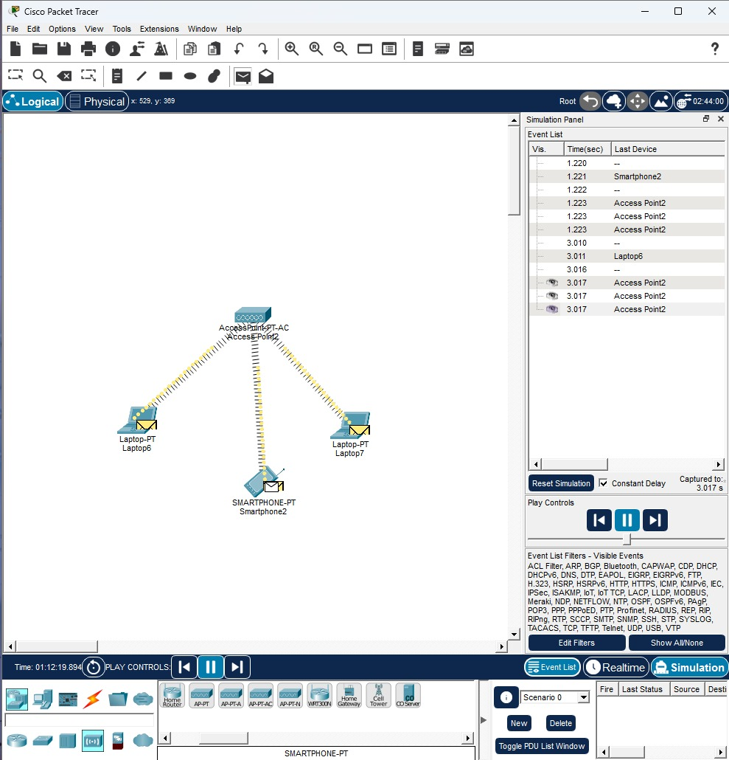

A basic MANET was successfully created and packet communication was observed using Cisco Packet Tracer simulation mode.

PRACTICAL NO 07
Aim : Implement a Wireless sensor network simulation.

CONCEPT:

WSN consists of:
- Multiple IoT Sensors
- IoT Gateway / Home Gateway
- Server / Cloud
- Wireless communication (IEEE 802.15.4 or WiFi in Packet Tracer) Cisco Packet Tracer uses IoT Sensors from the IoT section.

STEPS TO CREATE WSN SIMULATION

STEP 1: Open Packet Tracer Create a new project.
STEP 2: Add IoT Devices / Sensors
From the IoT Devices → Sensors category, drag: Temperature Sensor
Humidity Sensor Motion Sensor Light Sensor
(Choose 2–4 sensors for basic WSN) Place them in the workspace.
STEP 3: Add a Wireless Gateway (Important) Go to:
IoT Devices → Home Gateway

Drag Home Gateway to center workspace. This will act as the WSN Coordinator / Hub.

STEP 4: Connect Sensors to the Gateway

Click each sensor → Config Tab
- Turn Power ON
- Go to Wireless Settings
- Set:

SSID: WSN
Security: None Channel: 6 Type: IoT

4. Configure IoT Server Address Server IP: 192.168.1.2
Do this for every sensor.

STEP 5: Assign IP to Home Gateway

Click Home Gateway → Config → Wireless Set:
SSID: WSN IP: 192.168.1.1
Subnet: 255.255.255.0

This gateway acts like a sink node.

STEP 6: Add a Server (For Data Collection) Go to End Devices → Server
Rename it WSN-Server Set IP:
Click → Desktop → IP Configuration IP Address: 192.168.1.2
Subnet Mask: 255.255.255.0
Gateway: 192.168.1.1

This server will receive sensor readings. STEP 7: Connect Server to Gateway Use Copper Straight Cable between:
Server → Home Gateway (Ethernet) This connects the WSN to a backend. STEP 8: Check Sensor Connectivity
On a sensor → Desktop → Command Prompt Try ping:
ping 192.168.1.2

(WSN-Server IP)

If replies come → WSN works.

STEP 9: Enable Simulation Mode Switch from Real-Time → Simulation This allows seeing data packets.
STEP 10: Generate Sensor Traffic

Click a sensor →
Desktop → IoT Monitor / Add Event / Generate Data

OR
Use Add Simple PDU (lightning icon):
- Click Sensor
- Click Home Gateway or Server STEP 11: Run Packet Animation
Click:
Play Simulation You will see:
  - Small envelopes moving from sensors → gateway → server
  - This represents wireless WSN data communication

OUTPUT:
  - IoT sensors connect wirelessly to a central Home Gateway.
  - Server receives sensor data.
  - Packet animation shows sensor → gateway → server communication.
  - This demonstrates a basic WSN.
RESULT: A Wireless Sensor Network (WSN) was successfully implemented in Cisco Packet Tracer using IoT sensors, a wireless gateway, and a server.

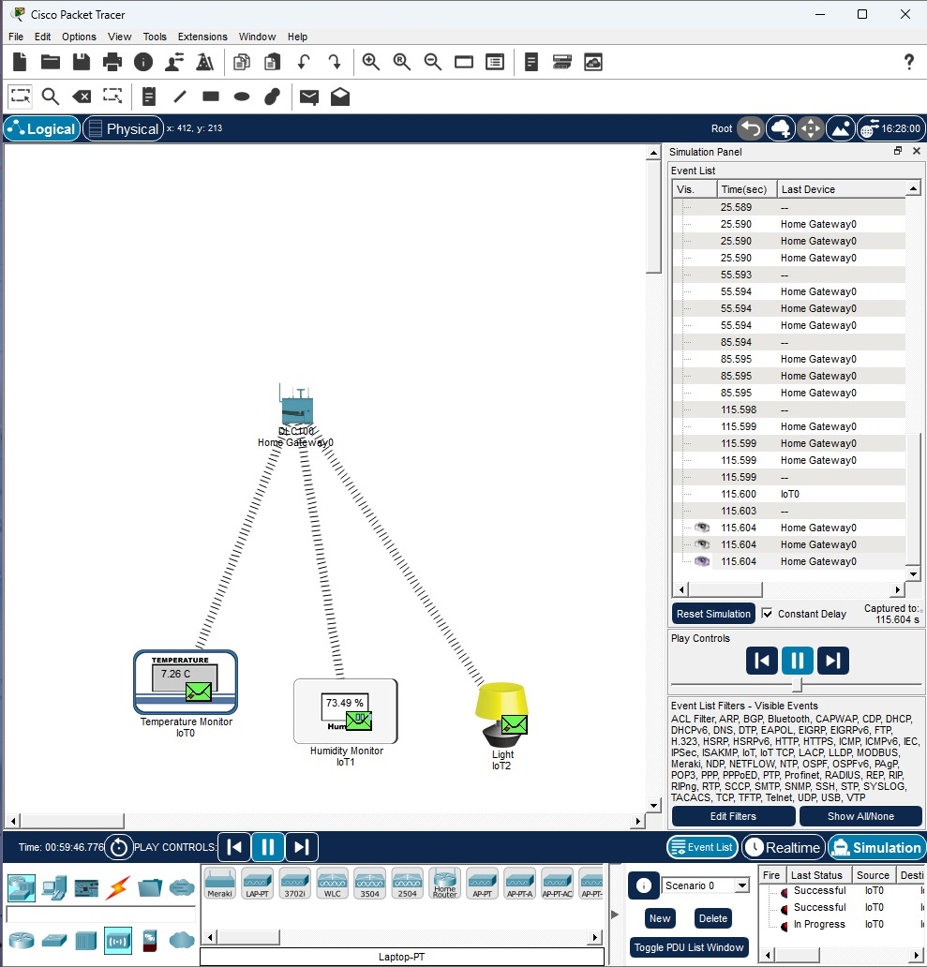

Practical No:08

Aim :Create MAC protocol simulation implementation for wireless sensor Network.
Cisco Packet Tracer does not directly support WSN MAC protocols like CSMA/CA, TDMA, SMAC, TMAC, etc.,
but you can simulate basic MAC behavior using Wireless devices + custom event timing.

Steps:
- Open Cisco Packet Tracer
Start a new project.
- Add Wireless Sensor Nodes
Packet Tracer has IoT Wireless devices that behave like sensor nodes. Add these:

Go to End Devices → IoT devices
  - Choose IoT Sensor
(Temperature, Humidity, Light – any type) Place sensors on the workspace.
- Add a Wireless Gateway / Access Point

Go to Network Devices → Wireless Devices
  - Add Home Gateway or Wireless Router
This acts as the sink node / base station.
- Connect All Sensors to the Network
  - Click each sensor → Config

Set Wireless connection ON
  - Select SSID of your Wireless Router (Example: “WSN-Network”)
- Assign IP Addresses
For simple simulation:
  - Router: DHCP ON
  - Sensors: Set mode → DHCP
All devices now get automatic IP addresses.
- Implement Simple MAC Behavior:
Packet Tracer does NOT allow coding MAC protocols directly
but you can demonstrate MAC operation by controlling the timing of transmissions. To show CSMA/CA-like behavior:
- Click Simulation Mode (bottom right).
- Select Add Simple PDU.
- Send a message from Sensor → Router.
- Send messages from multiple sensors at the same time.
- Observe:

If two devices transmit together → collision warning appears
  - Devices retransmit after backoff → simulates MAC protocol.
- Simulate TDMA (Time Division MAC)
You can simulate time slots manually:

Steps:
- Pause simulation.
- Send a packet from Sensor 1.
- Wait a few seconds → send from Sensor 2.
- Repeat for Sensor 3.
This shows no collision, like TDMA.
- View Packet Flow
In simulation mode:
  - Each sensor sends data frames.
  - The router receives them.
  - You see MAC-layer frames in the event list:
    - RTS/CTS (if enabled)
    - ACK frames
    - Data frames
    - Retransmissions
- Analyze the Result
You can observe:
  - Collisions
  - Packet timing
  - Delivery success
  - Backoff times
This is enough to show basic MAC protocol functionality in a WSN.

Output:

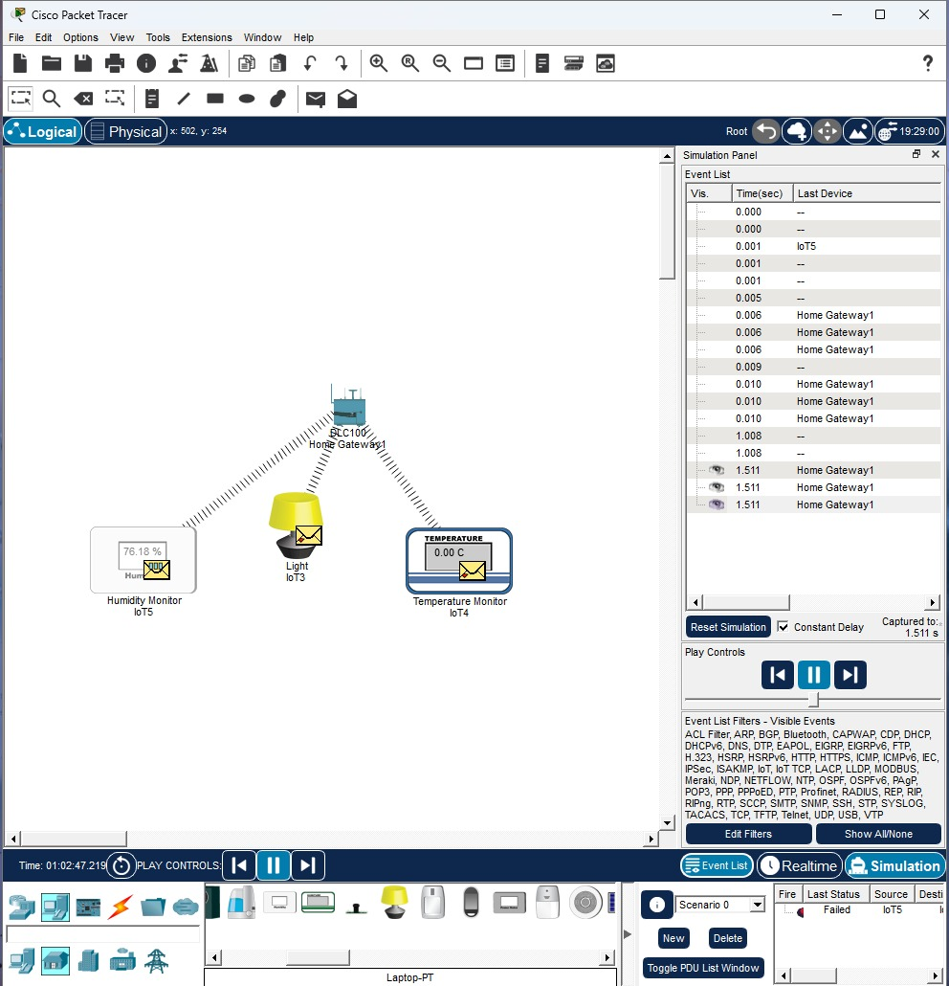
Practical No:09 Aim: Simulate Mobile Adhoc Network with Directional Antenna Simple Step-By-Step Instructions:
Step 1: Open Cisco Packet Tracer
Just open the software → start a new blank project.
Step 2: Add Wireless Devices
- Go to End Devices (bottom-left).
- Choose Wireless devices like:
  - Wireless Router
  - Wireless End Device
  - Or Generic Laptop with wireless. For MANET, use at least 3 wireless devices:
- PC0
- PC1
- PC2
Place them on the workspace.
Step 3: Change Their Antennas to Directional

- Click on PC0 → Physical tab.
- Turn OFF the device (power button).
- Go to WPC300N Wireless module view.
- Remove the default antenna.
- Add a Directional Antenna (WRT300N) from the antenna options.
- Turn device ON again. Repeat for all PCs.
Step 4: Configure MANET Mode

- Go to Config tab → Wireless.
- Set:
  - Adhoc mode = ON

SSID = MANET

Channel = same for all nodes
  - Tx Power = maximum
- Set the same SSID for all nodes so they can communicate.
Step 5: Give IP Address to Each Node
Simple static IP setup:
Device | IP Address
PC0 | 192.168.1.1/24
PC1 | 192.168.1.2/24
PC2 | 192.168.1.3/24
Steps:
- PC0 → Desktop → IP Configuration → enter IP
- Do same for PC1, PC2.
Step 6: Adjust Direction and Angle of the Antenna
- Click a device.

Go to Config → Wireless → Direction.
- Set:

Direction (0° – 360°)
  - Beamwidth (for example 60°) Make antennas face each other.
Step 7: Test Communication (Ping)
- Open PC0 → Desktop → Command Prompt.
- Type:
ping 192.168.1.2
You should receive reply. Try:
ping 192.168.1.3
If the antennas do not face each other → packets will drop.
Step 8: Show Mobility (Movement)
- Select a PC → move it to another place on the canvas.
- Check ping again.
- Note how signal breaks if device moves outside directional range.
Step 9: Optional – Add Animation

  - Use Simulation Mode.
  - Send simple PDU from PC0 → PC1.
  - You will see packet travelling only inside antenna coverage area.

Output:

